**Batch: D - 1 Roll No.: 16010122096**

**Experiment / assignment / tutorial No. 03**

**Grade: AA / AB / BB / BC / CC / CD /DD**

**Signature of the Staff In-charge with date**

**Experiment No.:3**

|  |
| --- |
| **TITLE:** Building and configuring simple topology using Network tool - CISCO PACKET TRACER. |

**______________________________________________________________________________**

**AIM:** To build and configure simple network topology using CISCO Packet Tracer.

Packet Tracer is a network simulation program that allows students to experiment with network behaviour and ask “what if” questions. Packet Tracer provides simulation, visualization, and authoring, assessment, and collaboration capabilities and facilitates the teaching and learning of complex technology concepts.

**______________________________________________________________________________**

**Expected Outcome of Experiment:**

**CO:**

**_____________________________________________________________________________**

**Books/ Journals/ Websites referred:**

1. <http://www.google.com>
2. A. S. Tanenbaum, “Computer Networks”, Pearson Education, Fourth Edition
3. B. A. Forouzan, “Data Communications and Networking”, TMH, Fourth Edition
4. [CISCO PACKET TRACER 8.0.1 and Higher version (free download)](https://mega.co.nz/#!q4p0wS7Z!J9jkMwXzZSO4zP1kZX632VFYyxNzwPUhvx8f8Ejyen0 (53.3 MB))

**Pre-Lab/ Prior Concepts:** Simple Network flow

**______________________________________________________________________________**

**New Concepts to be learned**: Purpose of this lab is to become familiar with building topologies in Packet Tracer. ______________________________________________________________________________

**Stepwise-Procedure:**

Creating a simple LAN network using packet tracer:

Step 1: Select two PCs (PC0 and PC1) from the end devices and one fast ethernet switch (2950/24 ports)

Step 2: Connect PCs and switch via copper cable from the panel. Connection can be verified by appearance of all green dots on the links.

Step 3: For PCs to communicate click on PC0.

* Dialog box for PC0 appears
* Click on desktop applications by packet tracer.
* Go to IP configuration.
* Enter IP address to identify host i.e. PC0 (for example: 192.168.1.1)
* Subnet mask-by default already set one can change it as per his/her specification.

Step 4: Repeat step 3 for PC1

Step 5: Ping both the PCs and check their working status.

Step 6: Simple PDU (Protocol Data Unit) to simulate network traffic by sending ICMP PDU to assess the network traffic. View simulation in simulation mode

**IMPLEMENTATION:** (printout of simulation code)

**Network Topologies:**

1. **Topology with a HUB**

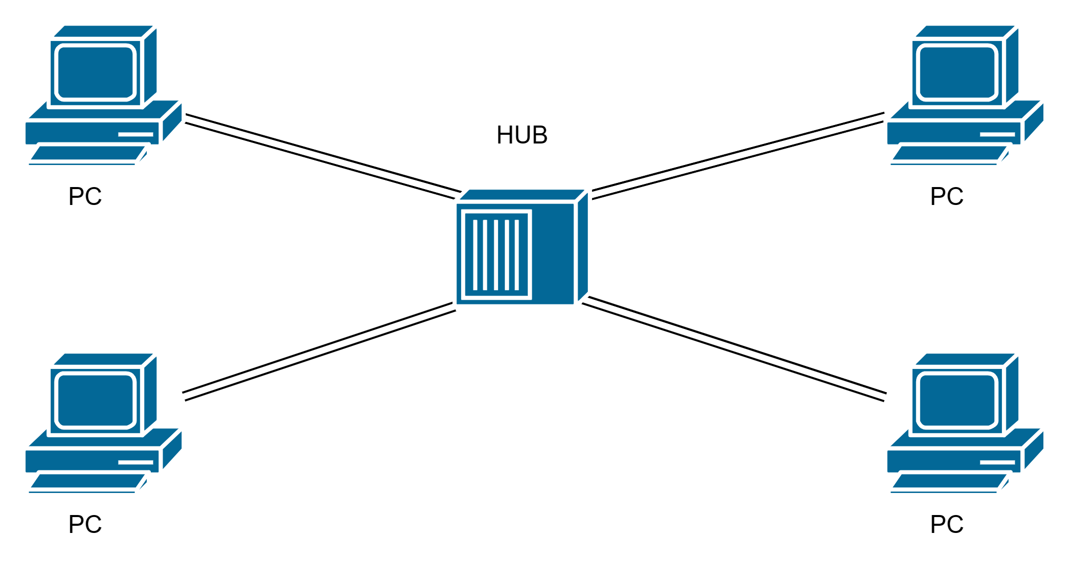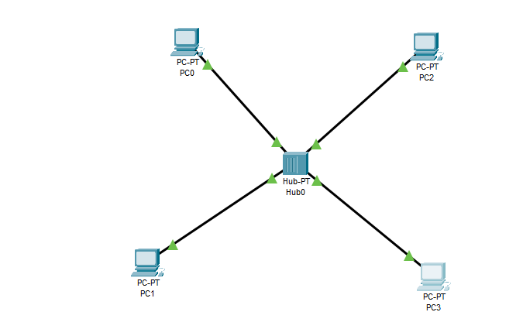

**IP Configuration:**

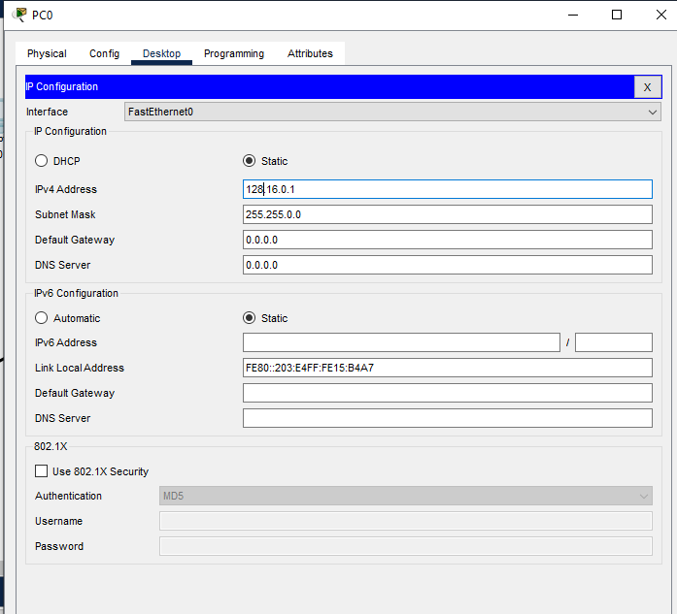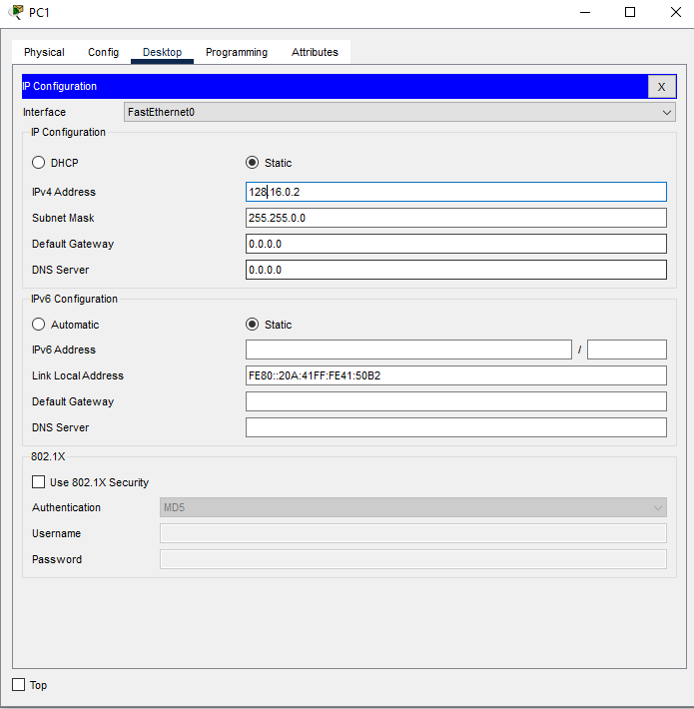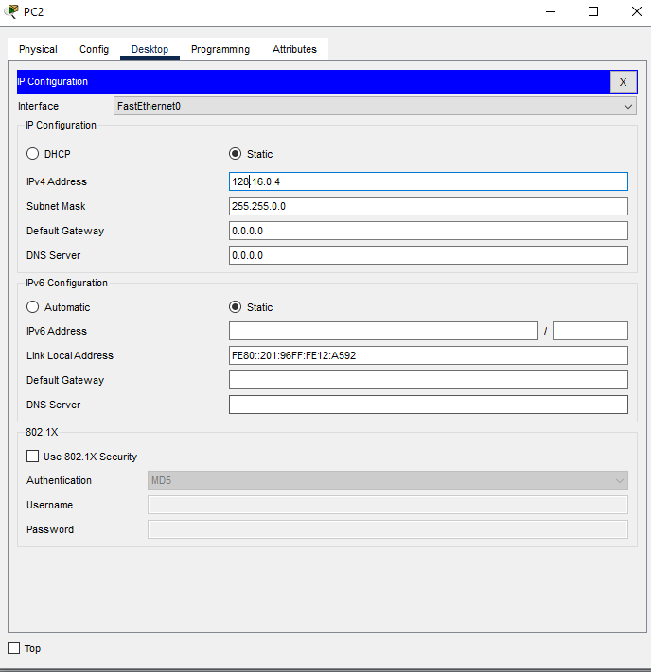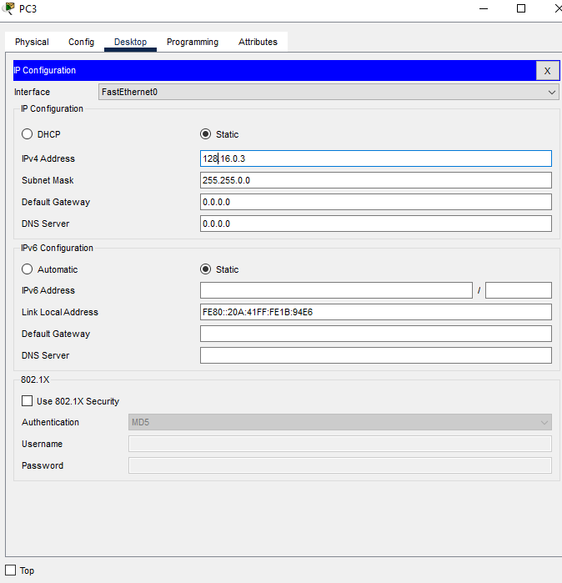

**2. Topology with a Switch**

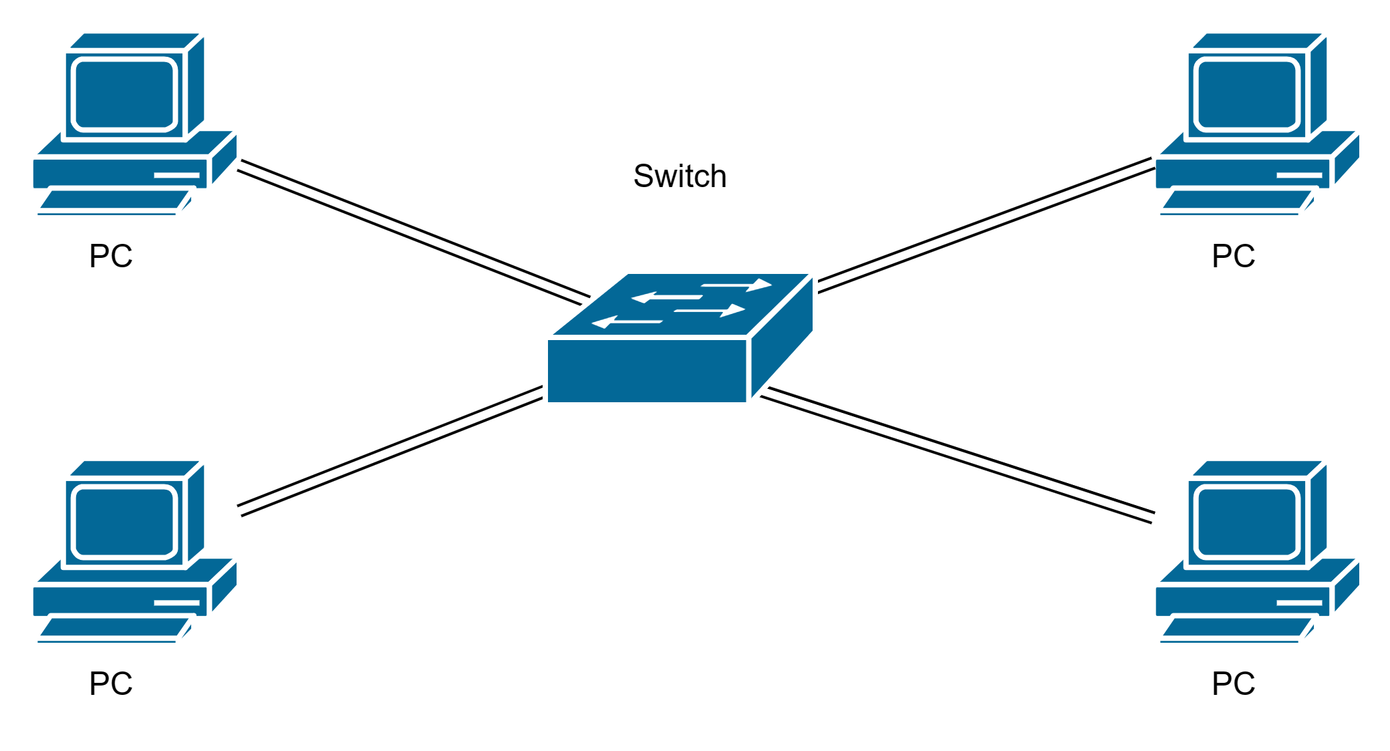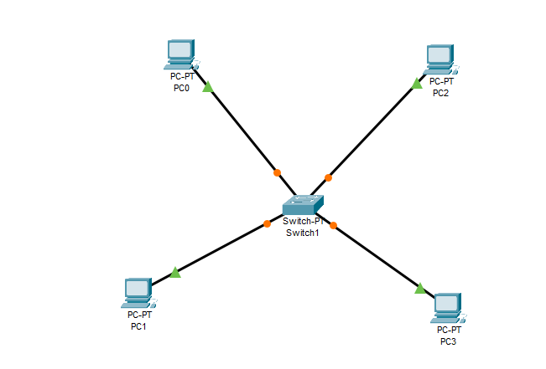

**IP Configuration:**

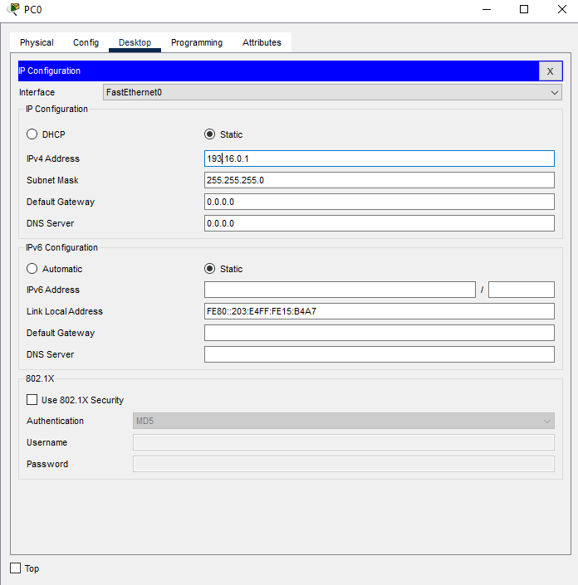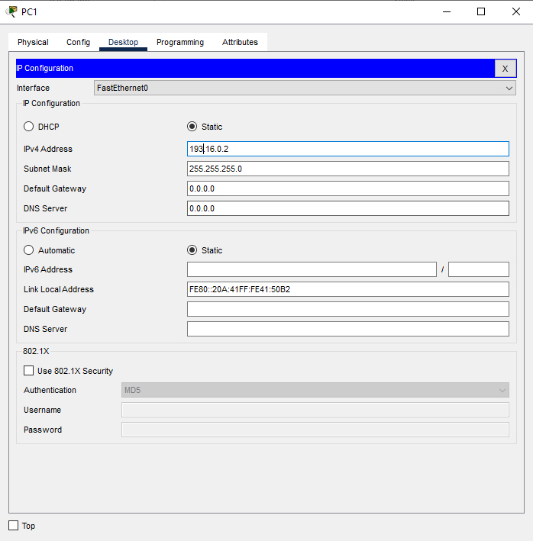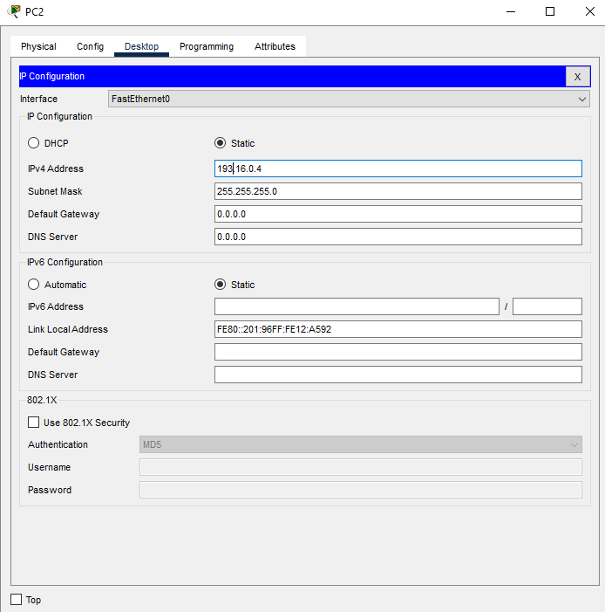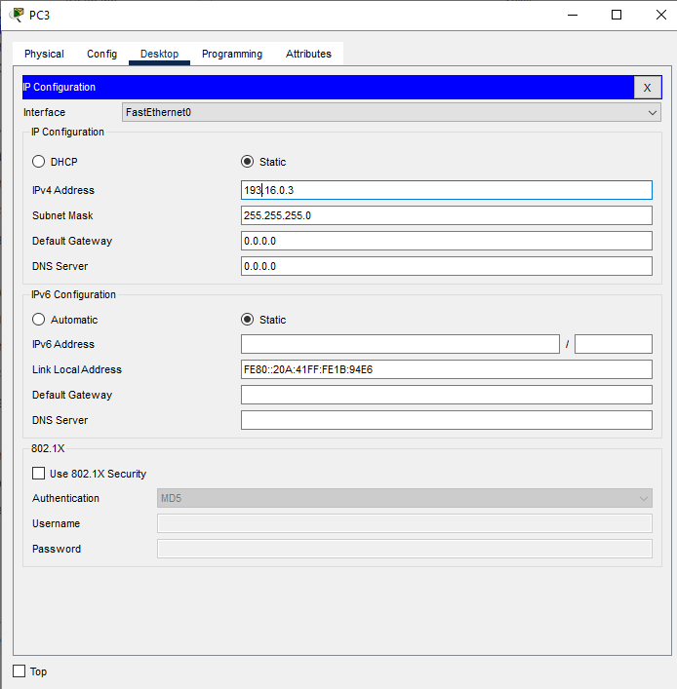

**3. Topology with two switches**

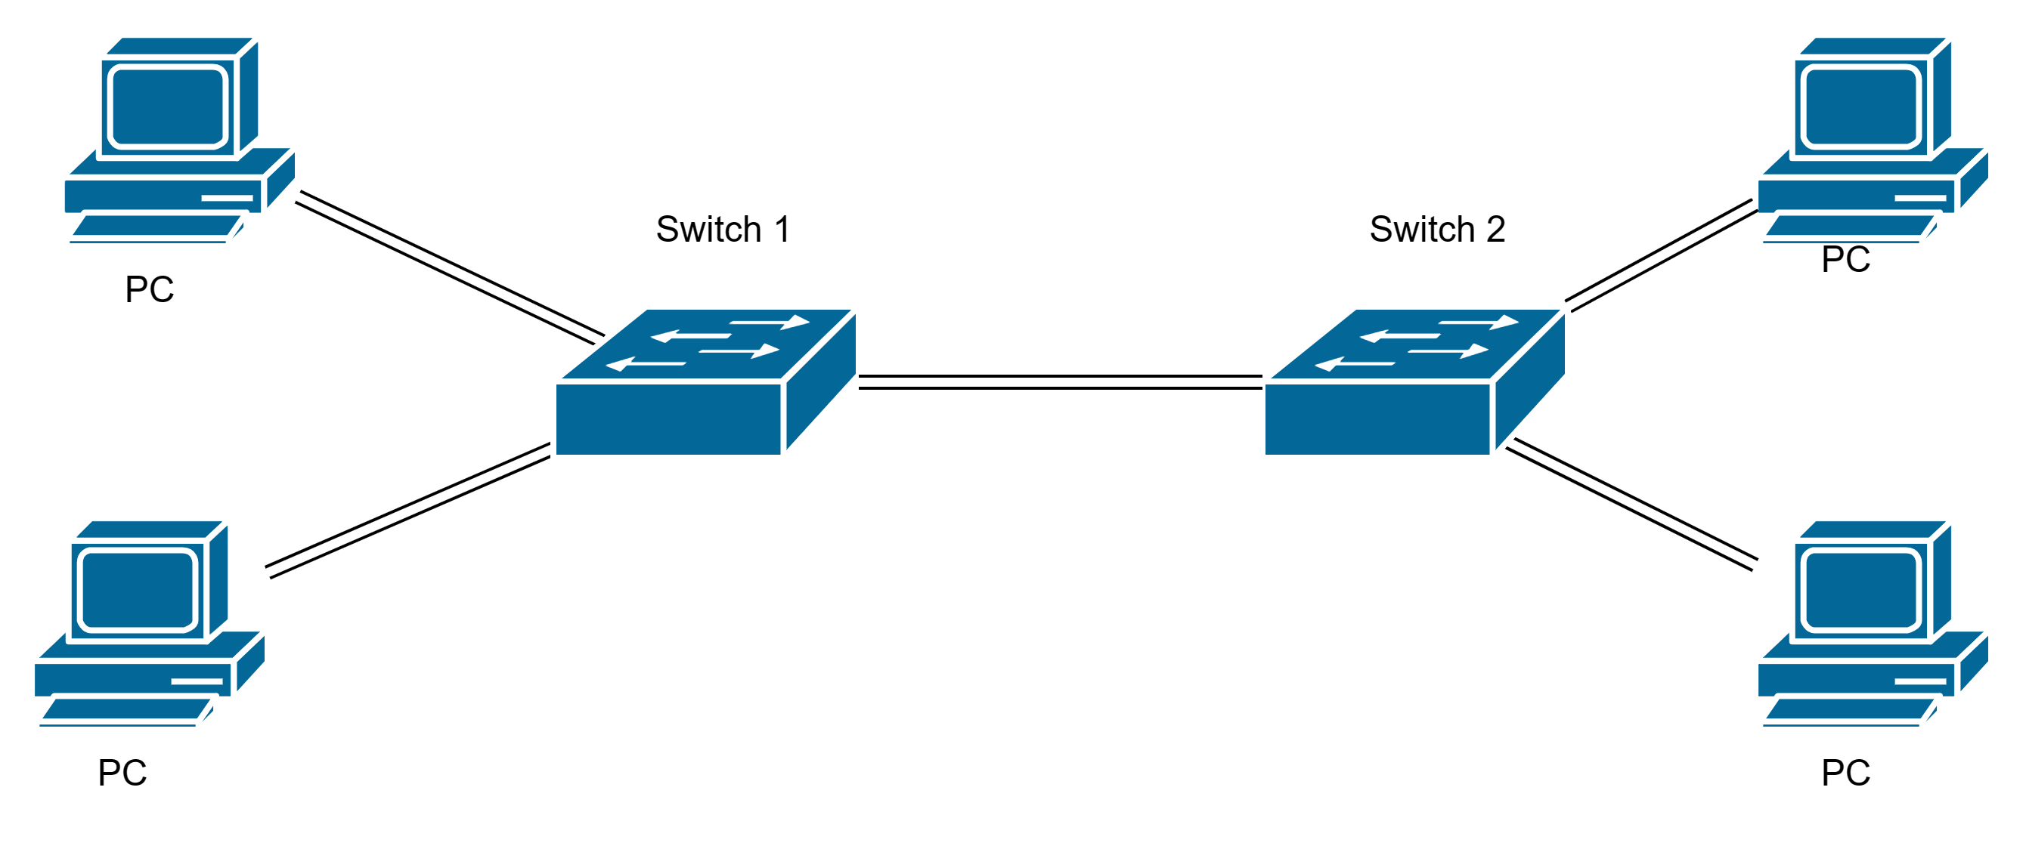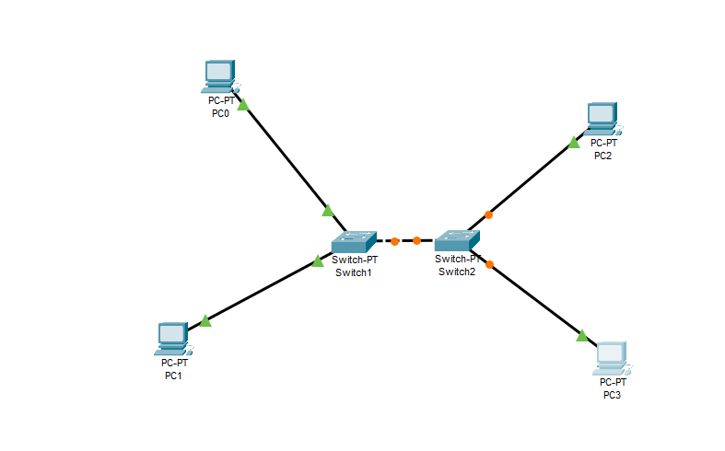

**IP Configuration:**

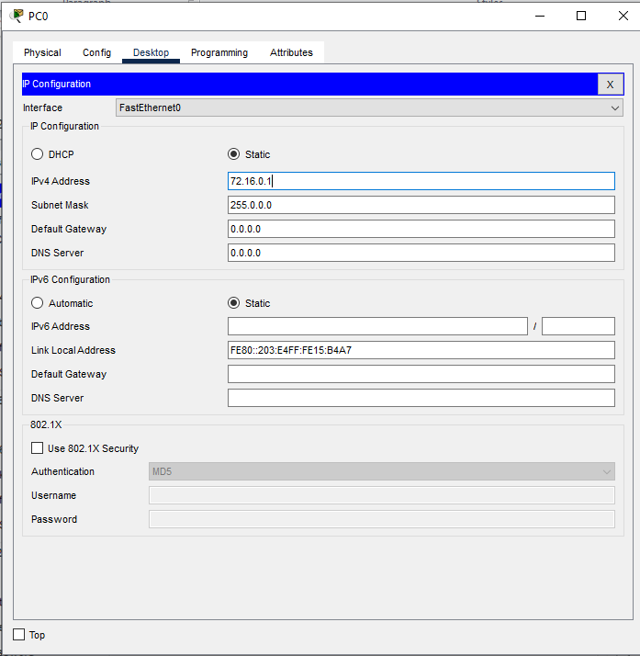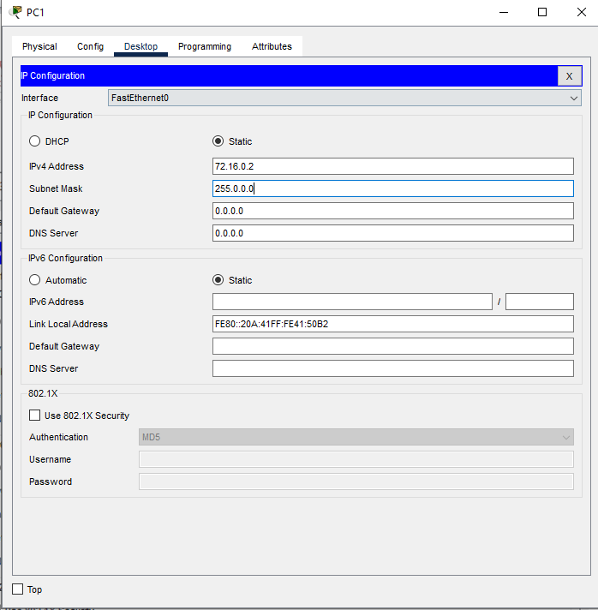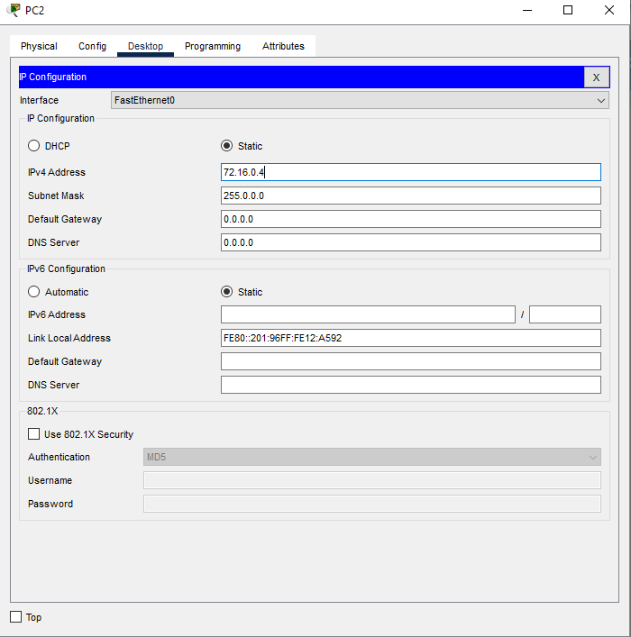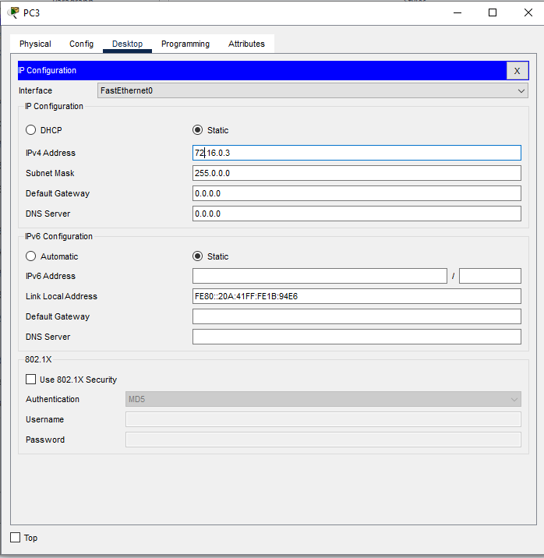

1. **Topology with 3 switches in a loop (Concept of STP)**

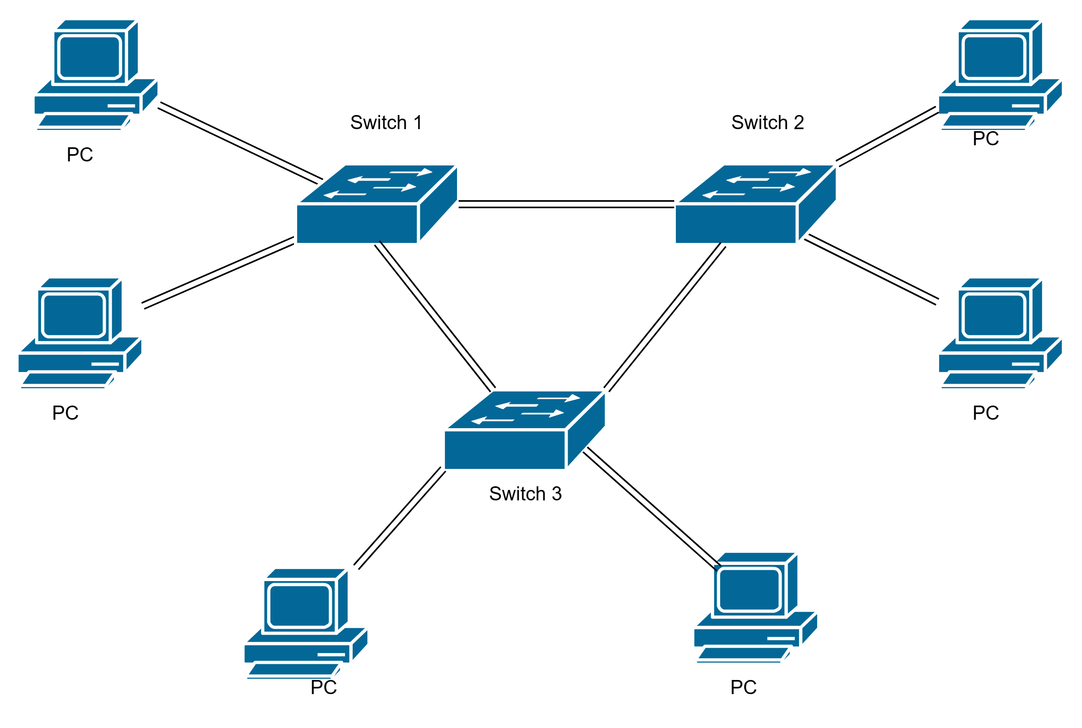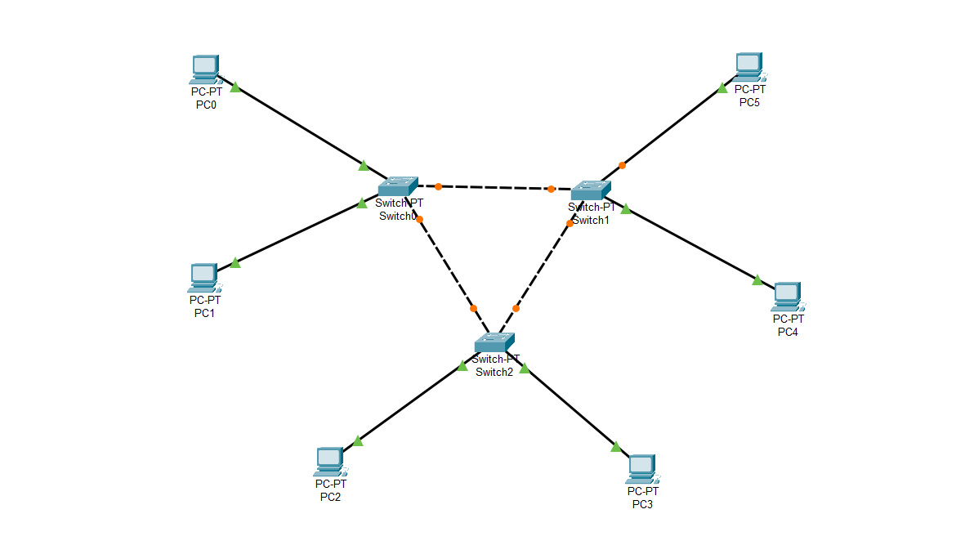

**IP Configuration:**

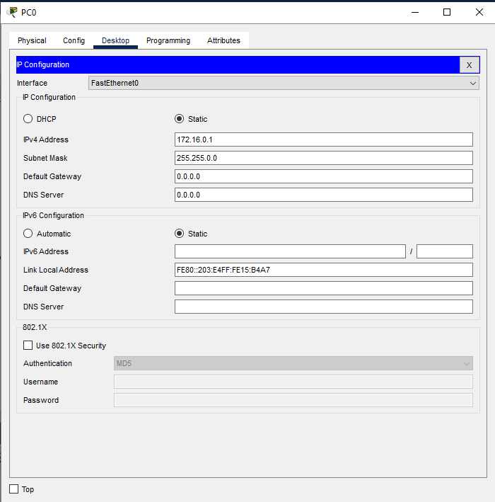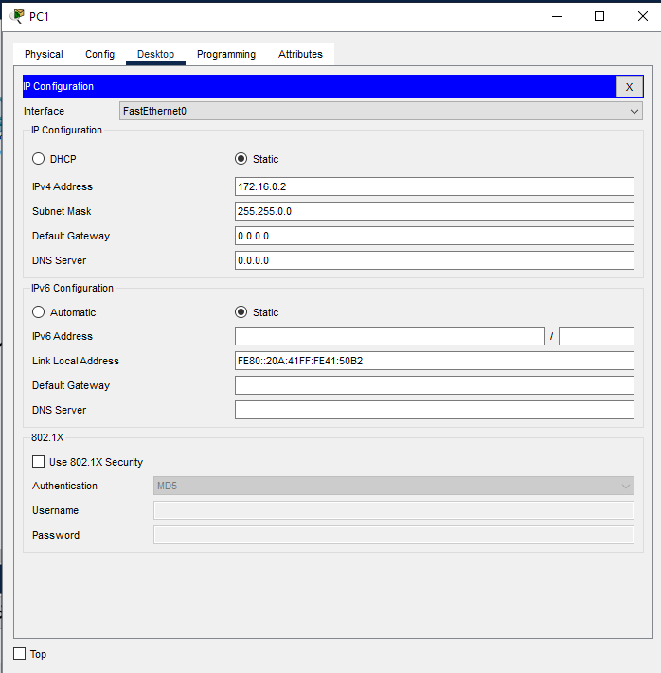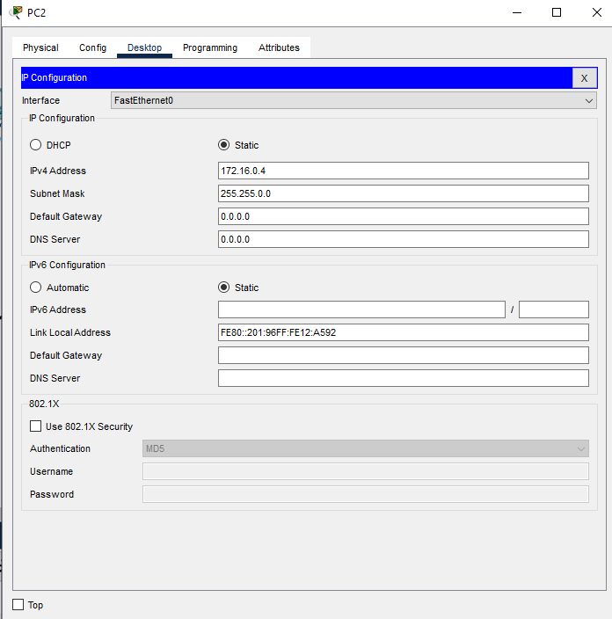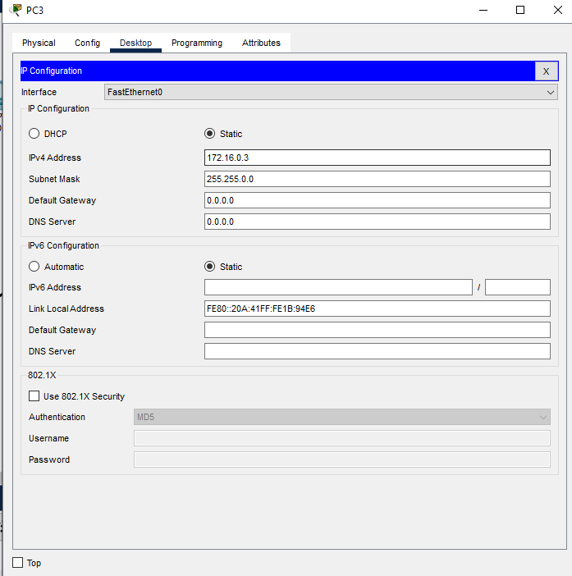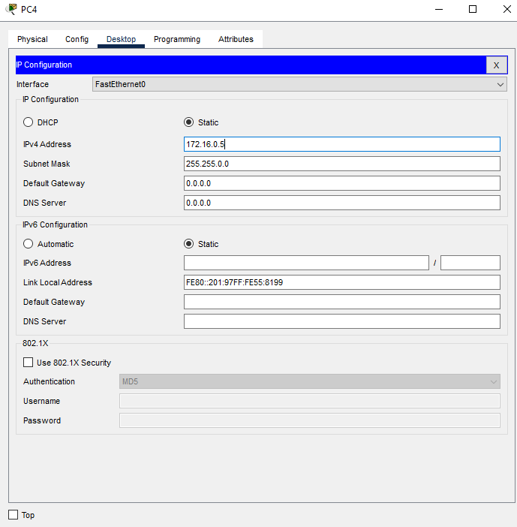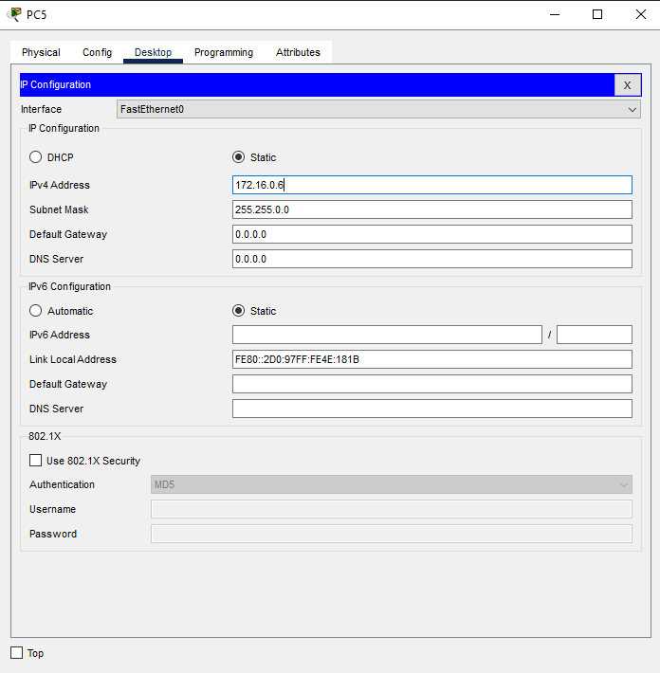

**CONCLUSION:** In conclusion, building and configuring a simple network topology using CISCO Packet Tracer enhances understanding of network fundamentals and provides hands-on experience in simulating real-world networking scenarios.

**Post Lab Questions**

1. **List features of CISCO packet tracer.**

Features of CISCO Packet Tracer:

1. Network simulation and visualization
2. Real-time and simulation modes
3. Multi-user functionality for collaboration
4. Wide range of devices and connections
5. Activity Wizard for creating custom activities
6. Supports IoT device simulation
7. Comprehensive assessment and tracking tools
8. Cross-platform support (Windows, macOS, Linux)
9. **Explain difference between working of a Hub and a Switch in a given topology.**

Difference between Working of a Hub and a Switch in a Given Topology:

* **Hub:** Broadcasts data to all devices in the network, causing network congestion and collisions. It operates at OSI Layer 1 (Physical Layer).
* **Switch:** Forwards data only to the specific device based on MAC address, reducing congestion and improving efficiency. It operates at OSI Layer 2 (Data Link Layer).

**Date: 03 / 08 / 2024 Signature of faculty in-charge**